**Sprint End Progress Check:** GotoGro-MRM

**Team Details**

|  |  |
| --- | --- |
| **Team Name:** | MSP 14 |
| **Tutorial:** | Tue 2:30 ATC325 |
| **Tutor:** | Dr Kaberi Naznin |

|  |  |
| --- | --- |
| **Members:** | |
| Dylan Jarvis | 102093138 |
| Rabya Tayal | 103144215 |
| Simon Tran | 103602807 |
| Thomas Babicka | 103059885 |
| Cody Cronin-Sporys | 103610020 |
| Nicholas Dyt | 101624265 |

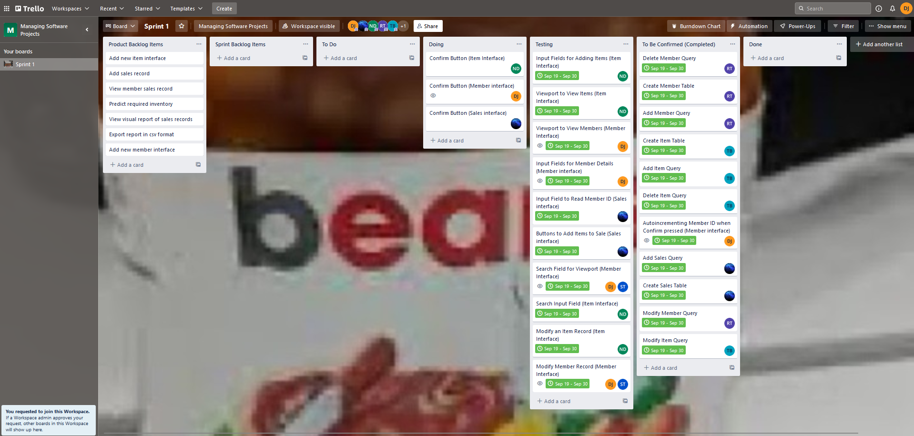**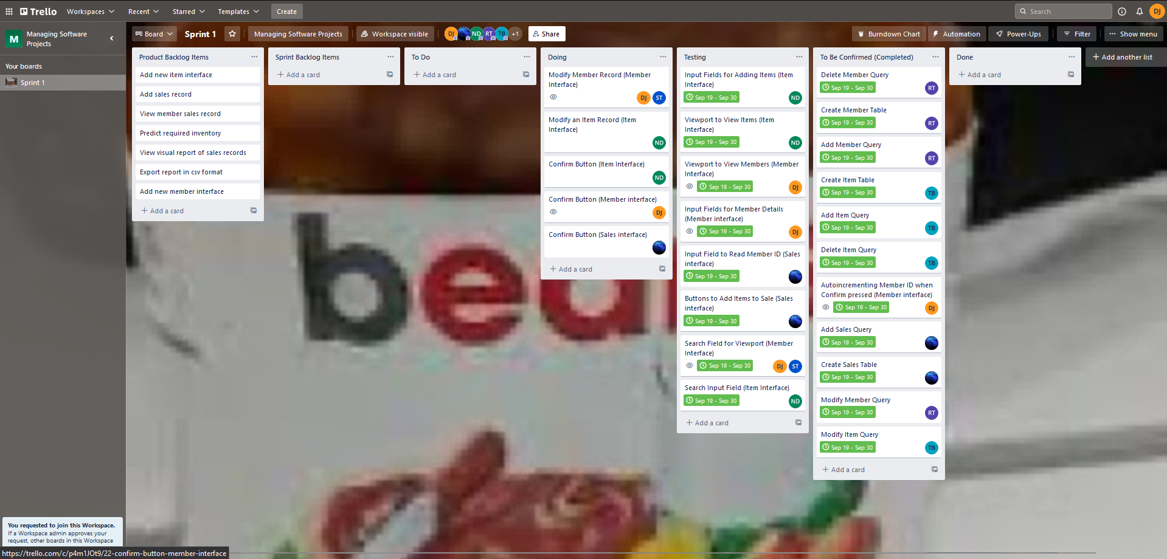Trello Days 6-10**

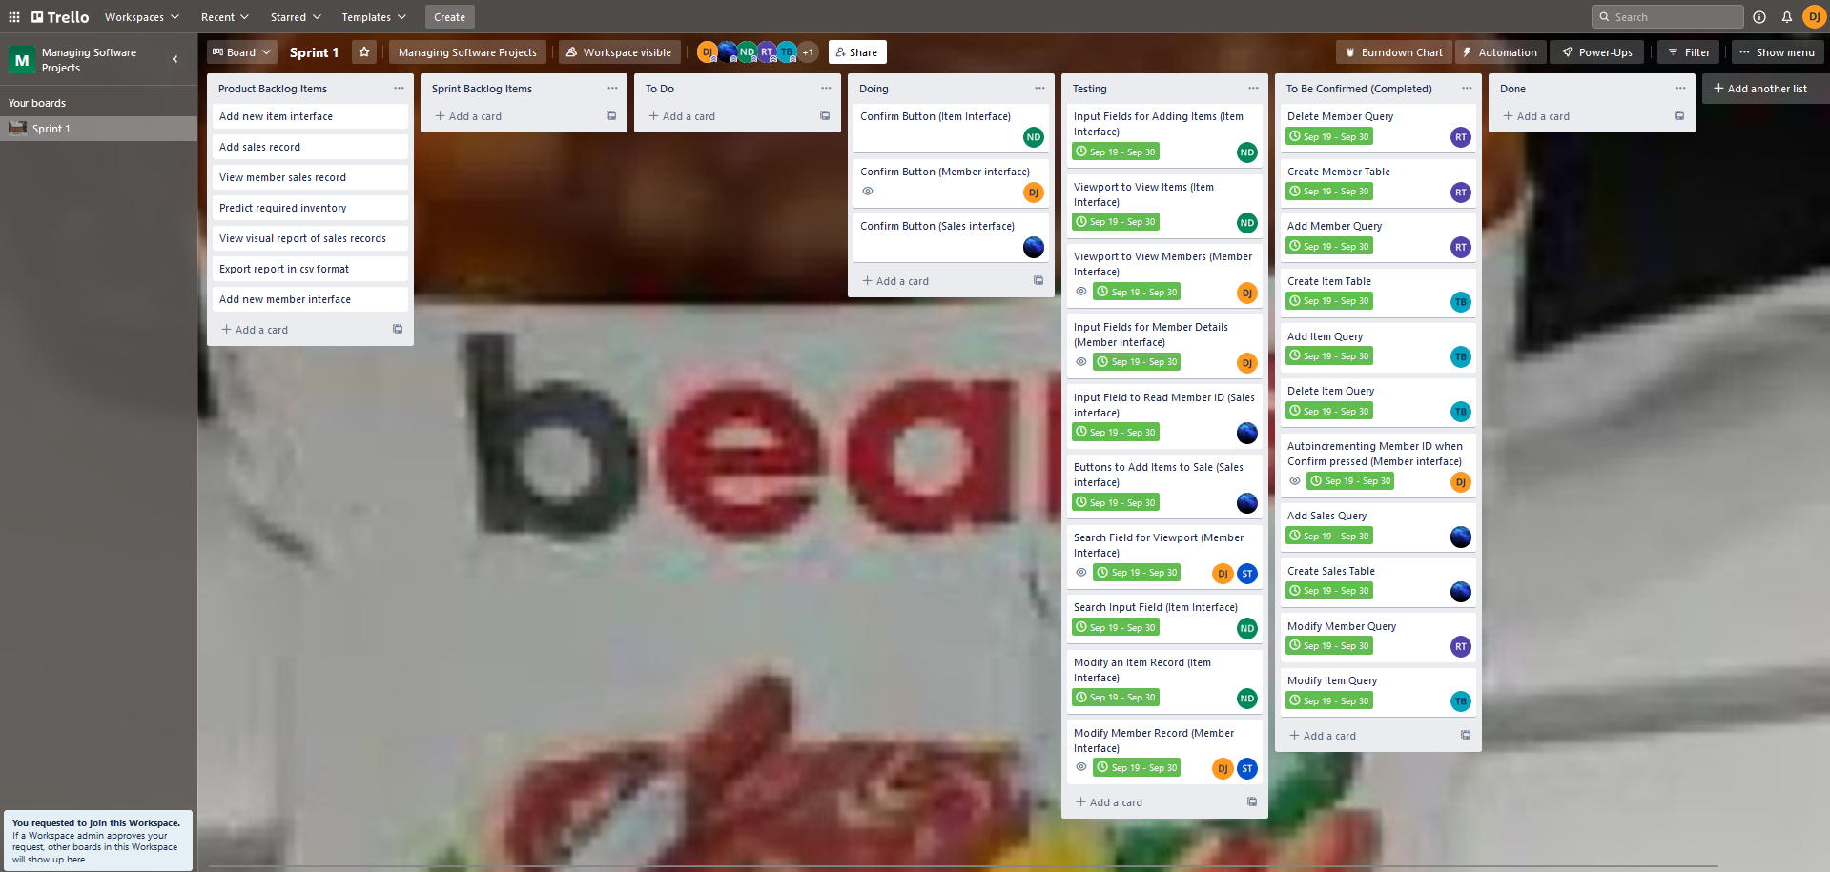

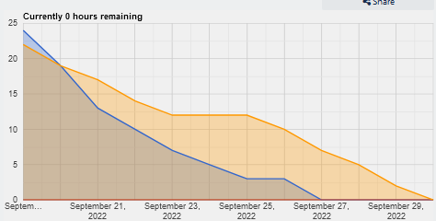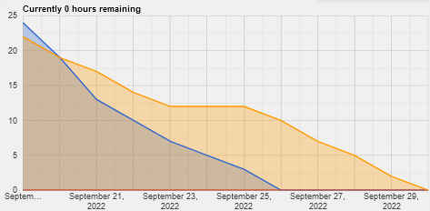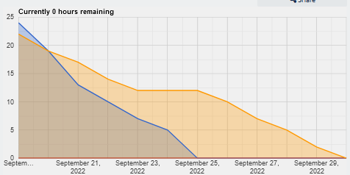**Burndown Chart Days 6-10**

The burndown charts and the Trello boards show that our team was ahead of schedule the entire sprint. That said, the overall time spent on the project was very close to the estimate. The rapid burndown is a product of the difficulty of the items, with the easiest/lowest time commitment items being done first.

**Group Meeting Notes**

The group meetings were conducted over discord and involved basically checking in with each member and their given tasks to discuss if they had completed it, needed more time, or needed more help. The image below summarises the content discussed over the last 5 days:

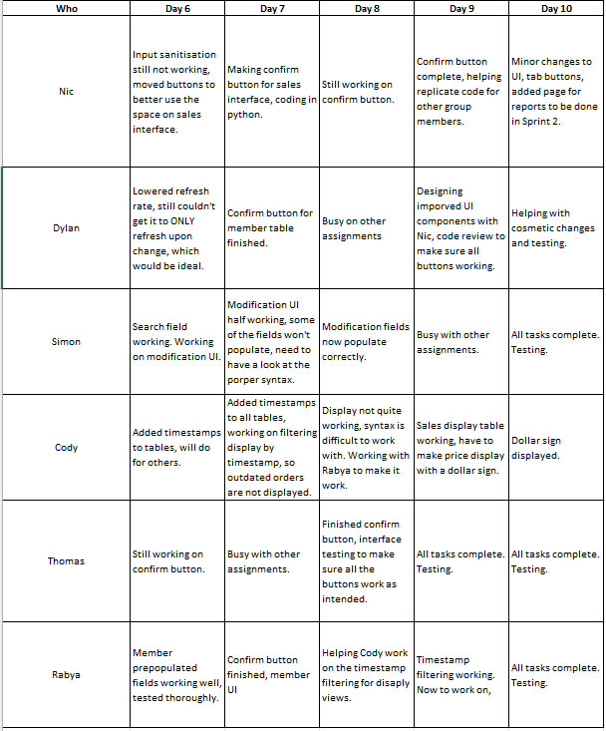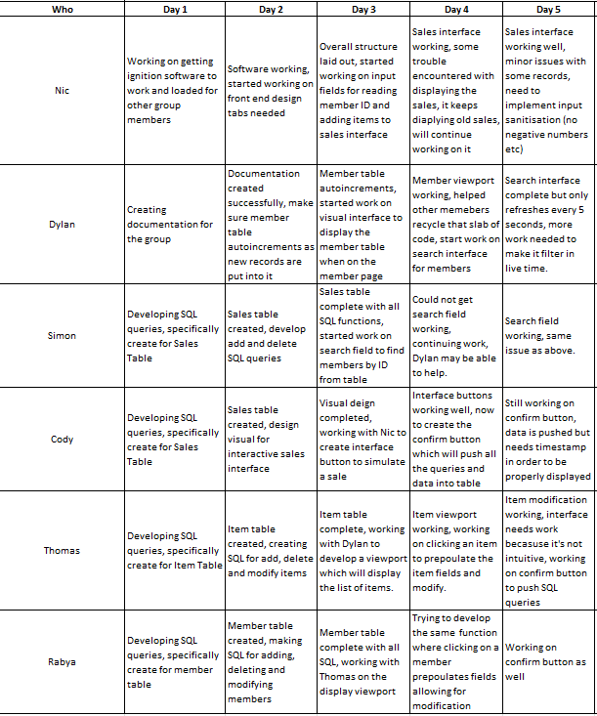

**Github Repository Days 1-5**